## Michal Kubiak T00205890

## Taxi Rental Requirements Specifications

The program I have designed is a taxi rental management system, it provides a function of logging in as admin and adding a taxi driver and logging in as a user once signed up and checking prices for your selected destination from a list of drivers on any specified day. On application start, the user is prompted with a login menu, which has an option of signing up or logging in with credentials. The system will insert user data upon registration if valid, and pull username and password from database upon login. If user is not found the system will display an error message.

The main sections of the program are **Admin, Book Taxi Now and My Account.**

**Admin**

Within the Admin section, once logged in as admin, the user may add a driver to the database. The driver credentials are Driver, Make, Mobile, Rate per KM, location and days available. Upon clicking submit, upon validation the driver will be added to the database and will be visible upon picking a day in the Make Booking section if the users location matches the driver’s location. Else the window will display an appropriate validation error message.

**Book Now**

The Book Taxi Now section initially loads with a pick-a-day combo box. Once the desirable day is selected a table view will appear with the drivers that are available on that day in the user’s location. Bare in mind this will not work if you are signed in as admin as the admin has a location of admin in the database. Once the user decides on the driver the user can enter the drivers ID next to the Book Now button

Once the button is pressed the Destination combo box will appear and the user is prompted to select one of the destinations they want to go. Once selected the rate of selected driver is taken into consideration and is multiplied by the distance from the user’s location to said destination and a label appears with the total price.

**My Account**

The My Account section can update the users account information in the database such as password and location. The user enters their username and the rest of the credentials, and if the passwords match and the username is found in the database the update query will execute thus changing the user’s information.

**Conclusions**

I wanted to point out some things that did not work for me or I could not figure out in this section of the document. My account section changed credentials for any username in the database as I did not find a solution to keeping the user logged in throughout the entire application until logged out. The windows are not all draggable. The customer class is not being used as the sign-up controller puts the data in the database and the login controller pulls the data. The Taxi class however is used in the Table View in the book now controller. Once the user picks a day the table view displays the drivers running on that day, but I could not figure out how to implement the LIKE in the select query to display drivers which could theoretically work multiple days a week. I would also implement an option of displaying all drivers in the admin panel and an option of deleting a driver there as well if I had more time.

SQL for the database is in the read me file, the drivers created have to have a location that matches the user otherwise it wont load any content in the table view as it will not find any drivers with the user’s location.

The project is a JavaFX application and it uses Gluon Scene Builder as the UI builder, this can be downloaded at <https://gluonhq.com/products/scene-builder/>. Once the project is opened right click on any FXML file in the Interfaces package and select open with scene builder at the bottom. A pop-up window should open to specify the .exe file of the scene builder, this can be found under the installation folder for example C://program files//Scene Builder//scenebuilder.exe. Once scene builder is opened you should click the setting button shown below

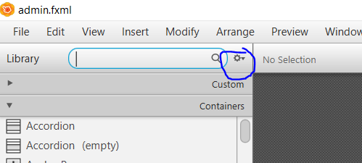

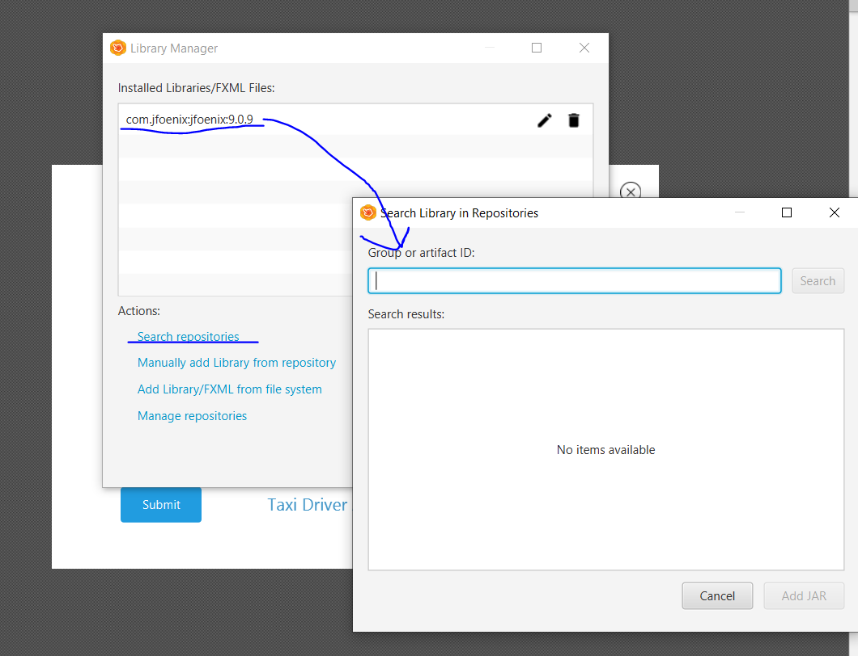

Then proceed to add the jar and select all components, which are used in my project and will not work without them.

Or follow the instruction given in this stack overflow thread.

<https://stackoverflow.com/questions/48841043/importing-jfoenix-library-to-scenebuilder-javafx>

The JFoenix.jar file is in the project folder.